***Anthem* Vocabulary** Name: _____________________________

Teacher’s name: _____________________

**Directions:** For each word, 1.) write out the definition and part of speech. Make sure you use the definition that corresponds to the part of speech. 2.) Construct an **original** well-written sentence containing the word and context clues. Underline or highlight the vocab word. 3.) Insert a picture (in Word go to Insert > Online pictures > search for a relevant picture) or insert an appropriate emoji. Save and upload to Focus when you are finished.

**Vocabulary list**

1.utopia (n)   
2. dystopia (n.)   
3. ego (n.)   
4. reason (n.)   
5. transgression (n.)   
6. ideology (n.)   
7. collectivism (n.)   
8. compulsory (adj.)   
9. manuscript (n.)   
10. peasants (n.)

11. lassitude (n.)   
12. solidarity (n.)   
13. pyre (n.)   
14. brine (n.)   
15. lodestone (n.)   
16. scornful (adj.)   
17. tunic (n.)   
18. solitude (n.)   
19. warrant (n.)   
20. sanction (n.)

**Example**

Amiable – adj. friendly; good natured

* Amiable people usually make friends easily.
* 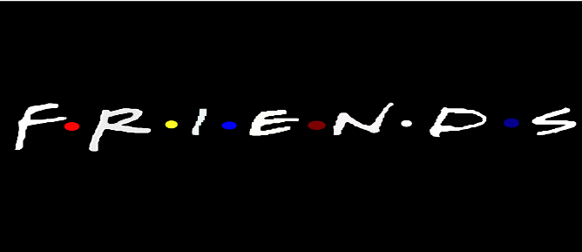

1. Utopia -